**Plan load tests by using Apache JMeter**

In this section, you follow Tim and Mara as they explore load testing and add load tests to the pipeline. The load tests use Apache JMeter to simulate a large number of users who access the web app simultaneously. The tests fetch the web content from the app that runs on Azure App Service, in the *Staging* environment.

Tim starts by bringing up the Apache JMeter user interface on a laptop. He runs a basic test plan. Then Tim and Mara export the test plan to a file that can be run from the command line. Finally, they add tasks to Azure Pipelines to run the load tests during *Staging*.

**Note**

For brevity, you don't need to install Apache JMeter on your local computer. You can just read along.

**Run load tests from Apache JMeter**

Mara drops in to see Tim.

**Mara:** Hi there. Are you ready to look at those load tests?

**Tim:** I sure am.

**Mara:** I've never written load tests. Remind me, what tool do you use to run them?

**Tim:** I use Apache JMeter. It's an open-source load-testing tool that analyzes and measures performance. The report it generates is an XML file. I normally use the JMeter graphical user interface, and I'm hoping we can integrate it into the pipeline.

**Mara:** I think we can. If the report is in a format that Azure Pipelines understands, it'll display a graph. I don't think we need any special hardware to run the tests, so we'll use a Microsoft-hosted agent to run them. *Staging* seems like the right place to run the tests because that's the phase that most closely resembles production.

It's a great idea to start with tools and tests that you're familiar with. Do you normally use any kind of script for load testing? Perhaps we could convert it to an automated test.

**Tim:** Let me walk you through my process.

**Create the test plan**

Tim brings up Apache JMeter on a laptop that runs Linux. Here's what it looks like.

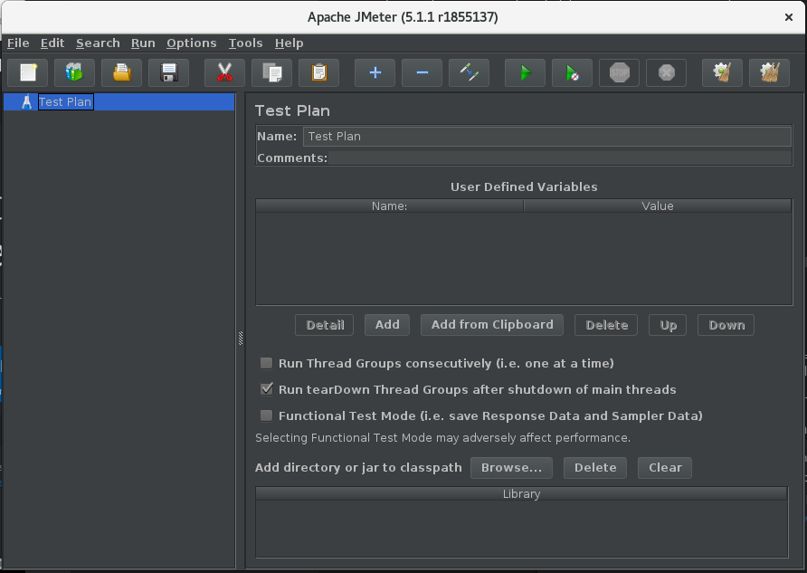

Tim then creates a new test plan file, named *LoadTest.jmx*. To the file, he adds a **Thread Group**. Each simulated user runs on its own thread. A thread group controls the number of users and the number of each user's requests.

The following example shows 10 simulated users (threads). Each user makes 10 requests. So the system gets a total of 100 requests.

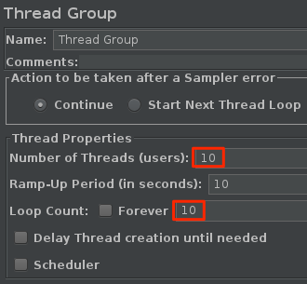

A *sampler* is a single request made by JMeter. JMeter can query servers over HTTP, FTP, TCP, and several other protocols. Samplers generate the results that are added to the report.

Next, Tim adds **Http Request Defaults** and an **Http Request** sampler to the thread group. He provides the host name of the *Space Game* website that runs in the **staging** environment on Azure App Service.

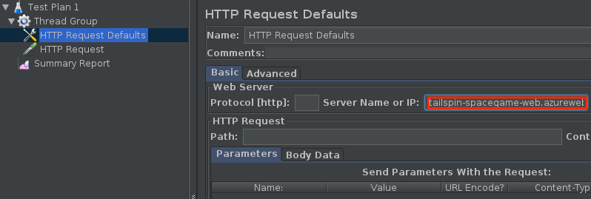

**Tip**

For reference, Microsoft hosts a version of the [**Space Game website**](http://tailspin-spacegame-web.azurewebsites.net/). Go there if you want to follow along with Tim's load tests.

**Tim:** This is a pretty basic test plan. We can explore many other options later. I think 100 requests is a good start to get meaningful results.

**Run the test plan**

**Tim:** JMeter enables you to run many kinds of tests. It's possible to run your test plan from the JMeter graphical user interface. But for load tests, the JMeter documentation recommends that you run the test plan from the command line.

Tim opens a terminal window and runs the test plan:

BashCopy

apache-jmeter-5.3/bin/./jmeter -n -t LoadTest.jmx -o Results.xml

The -n argument specifies to run JMeter in non-GUI mode. The -t argument specifies the test plan file, *LoadTest.jmx*. The -o argument specifies the report file, *Results.xml*.

JMeter runs and produces the report file, *Results.xml*. This example of the file shows the first few results:

**XML**

<?xml version="1.0" encoding="UTF-8"?>

<testResults version="1.2">

<httpSample t="180" it="0" lt="95" ct="35" ts="1569306009772" s="true" lb="HTTP Request" rc="200" rm="OK" tn="Thread Group 1-1" dt="text" by="40871" sby="144" ng="1" na="1">

<java.net.URL>http://tailspin-spacegame-web.azurewebsites.net/</java.net.URL>

</httpSample>

<httpSample t="174" it="0" lt="96" ct="38" ts="1569306009955" s="true" lb="HTTP Request" rc="200" rm="OK" tn="Thread Group 1-1" dt="text" by="40869" sby="144" ng="1" na="1">

<java.net.URL>http://tailspin-spacegame-web.azurewebsites.net/</java.net.URL>

</httpSample>

<httpSample t="160" it="0" lt="121" ct="35" ts="1569306010131" s="true" lb="HTTP Request" rc="200" rm="OK" tn="Thread Group 1-1" dt="text" by="40879" sby="144" ng="2" na="2">

<java.net.URL>http://tailspin-spacegame-web.azurewebsites.net/</java.net.URL>

</httpSample>

**Tim:** Each sample produces a node in the report. The t attribute specifies the response time in milliseconds (ms). That's what I'm interested in. Here you see three requests that took 180 ms, 174 ms, and 160 ms.

**Mara:** Earlier, you mentioned ideal request times. What were they?

**Tim:** Under a typical load, I like to see average request times of less than one second. No more than 10 percent of requests should take more than one second. You can configure JMeter to report statistics such as the minimum, maximum, and average response times or the standard deviation. I wrote a script to help provide this information.

**Mara:** Interesting! And the way you run this test plan will fit perfectly into our pipeline. You created the test plan through the JMeter GUI, but you ran the test plan from the command line. We just need to add your test plan to our Git repository and run JMeter in non-GUI mode from the command line.

But before we do that, one part remains. We can visualize the results if we provide them in a format that Azure Pipelines understands. Azure Pipelines can parse an XML file that contains test results, but the file needs to be in a supported format. Supported formats include CTest, JUnit (including PHPUnit), NUnit 2, NUnit 3, Visual Studio Test (TRX), and xUnit 2. I bet we can write an XSLT file that converts the JMeter results to JUnit.

**Tim:** Let's give it a try.

**Transform the report to JUnit**

XSLT stands for *XSL Transformations*, or *eXtensible Stylesheet Language Transformations*. An XSLT file resembles an XML file, but it enables you to transform an XML document to another XML format. Here, Mara and Tim write an XSLT file that converts JMeter output to JUnit.

Recall Tim's requirements for load tests:

* The average request time should be less than one second.
* No more than 10 percent of requests should take more than one second.

The XSLT file that Mara and Tim create meets these requirements. Here's what it looks like:

**XML**

<xsl:stylesheet version="1.0" xmlns:xsl="http://www.w3.org/1999/XSL/Transform" xmlns:math="http://exslt.org/math">

<xsl:output method="xml" indent="yes" encoding="UTF-8"/>

<xsl:template match="/testResults">

<xsl:variable name="times" select="./httpSample/@t" />

<xsl:variable name="failures" select="./httpSample/assertionResult/failureMessage" />

<xsl:variable name="threshold" select="1000" />

<testsuite>

<xsl:attribute name="tests"><xsl:value-of select="count($times)" /></xsl:attribute>

<xsl:attribute name="failures"><xsl:value-of select="count($failures)" /></xsl:attribute>

<testcase>

<xsl:variable name="avg-time" select="sum($times) div count($times)" />

<xsl:attribute name="name">Average Response Time</xsl:attribute>

<xsl:attribute name="time"><xsl:value-of select="format-number($avg-time div 1000,'#.##')"/></xsl:attribute>

<xsl:if test="$avg-time > $threshold">

<failure>Average response time of <xsl:value-of select="format-number($avg-time,'#.##')"/> exceeds <xsl:value-of select="$threshold"/> ms threshold.</failure>

</xsl:if>

</testcase>

<testcase>

<xsl:variable name="exceeds-threshold" select="count($times[. > $threshold])" />

<xsl:attribute name="name">Max Response Time</xsl:attribute>

<xsl:attribute name="time"><xsl:value-of select="math:max($times) div 1000"/></xsl:attribute>

<xsl:if test="$exceeds-threshold > count($times) * 0.1">

<failure><xsl:value-of select="format-number($exceeds-threshold div count($times) * 100,'#.##')"/>% of requests exceed <xsl:value-of select="$threshold"/> ms threshold.</failure>

</xsl:if>

</testcase>

</testsuite>

</xsl:template>

</xsl:stylesheet>

We won't delve into how XSL works here. But to summarize, this file first collects the following data from the JMeter output:

* Each HTTP request time.

It collects this data by selecting the t attribute from each httpSample element. (./httpSample/@t)

* Each failure message.

It collects this data by selecting all failureMessage nodes from the document. (./httpSample/assertionResult/failureMessage)

The XSLT file also sets the threshold value to 1,000 ms. This response time is the maximum that Tim defined earlier.

Given these variables, the XSLT file provides the total number of tests and the total number of failures. It then provides these two test cases:

* The average response time, and a failure if the average exceeds the threshold of 1,000 ms.
* The maximum response time, and a failure if more than 10 percent of requests exceed the threshold of 1,000 ms.

The results of the XSLT match the JUnit format, which Azure Pipelines understands. Mara and Tim name their XSLT file *JMeter2JUnit.xsl*.

**Mara:** Next we need an XSLT processor. Let's use **xsltproc**.

Tim installs **xsltproc**:

BashCopy

sudo apt-get install xsltproc

**Mara:** Now we need to transform the JMeter report to JUnit.

Tim runs **xsltproc**:

Bash

xsltproc JMeter2JUnit.xsl Results.xml > JUnit.xml

Here's the resulting JUnit file, *JUnit.xml*:

**XML**

<?xml version="1.0" encoding="UTF-8"?>

<testsuite xmlns:math="http://exslt.org/math" tests="100" failures="0">

<testcase name="Average Response Time" time="0.17"/>

<testcase name="Max Response Time" time="0.373"/>

</testsuite>

In this example, the average response time is 170 ms. The maximum response time is 373 ms. Neither test case generates a failure because both times fall below the threshold of 1,000 ms.

Shortly, you'll run these tests in the pipeline. You can think about *Results.xml*, the file that JMeter writes, as an intermediate file that's not published to the pipeline's test results. *JUnit.xml* is the final report file. This file gets published to the pipeline so that the team can visualize the results.

**Mara:** The tests succeeded! The test results stay in the pipeline. They don't go in source control. But your test plan does go in source control. And because the plan is a plain-text file and not a binary file, we can examine the Git history to track how the test plan changes over time.

**Tim:** These results look promising. I think we're ready to try the test in the pipeline. Can we do that now?

**Mara:** Absolutely. Let's test from your computer because you already have code for the *Space Game* website.